s



**REPUBLIC OF NAURU**

**NAURU FINANCIAL INTELLIGENCE UNIT**

Department of Justice and Border Control

Government Offices, Yaren District

Email: Rajas.Swamy@nauru.gov.nr Tel: +674 5573388

**UPDATED UN CONSOLIDATED LIST**

**ISSUEDON 17/9/20 (USA TIKME) 18/9/24 (NAURU TIME)**

**(NOTE -URGENT NOTICE FOR REPORTING ENTITIES AND STAKEHOLDERS)**

This is to inform you all that the United Nations Security Council as of today, *18th September 2024* which is 17th September 2024 in USA issued a fresh sanctions list.

Please see the attached urgent press release which is self-explanatory.

The List of sanctioned persons and entities appear over 63 pages. The list is on the UNSC website: [scsanctions.un.org/kv4v3en-all.html](https://scsanctions.un.org/kv4v3en-all.html)

This link is also found on the FIU Website: <https://justice.gov.nr/wp-content/uploads/2023/12/fiu_notice_on_united_nations_security_council_consolidated_list.pdf>

This Notice is issued to you all in accordance with the requirements of Section 109 of the *Anti-Money Laundering and Targeted Financial Sanctions Act 2023,* of which requires that this list is to be notified without any delay, not exceeding 24 hours.

The circulation of this List is in accordance with Regulation 42 and 44 of the *Anti-Money Laundering and Targeted Financial Sanctions (Financing of Terrorism and Proliferation Financing) Regulations 2023.*

You are required to go through the list and if your organisation or entity are holding onto any assets or funds in respect of any person or entity designated under this list, please contact FIU immediately:

1. Rajas Swamy
2. Bernard Grundler

The purpose of the list and what you are required to is also provided in the High Risk Guide. See link <https://justice.gov.nr/wp-content/uploads/2024/04/Anti-Money-Laundering-and-Targeted-Financial-Sanctions-High-Risk-Countries-Guideline-2023.pdf>

The Administrator pursuant to the Proceeds of Crime (Management and Disposal of Property) Regulations 2024 may also contact the FIU or your entity in respect of any of the assets or funds which may be covered by this new List. You are to respond to this Notice to the FIU within 14 hours of this receipt of this Notice. The Notice is also served to the respective emails of the entities, which are requested to please attend to it.

The Press Release relating to the update of the List from the UNSC states as follows:

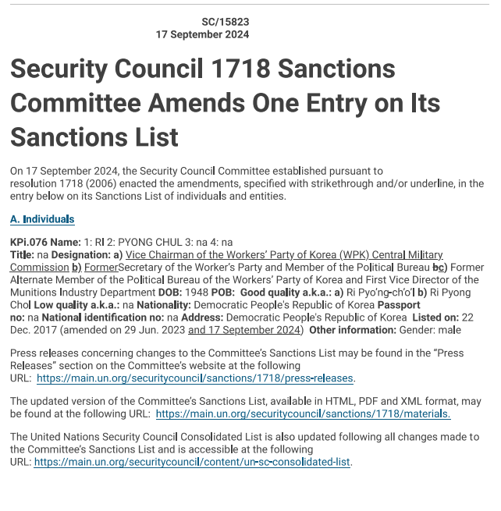

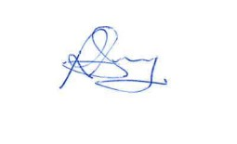

**Rajas Swamy**

**Supervisor – Financial Intelligence Unit**